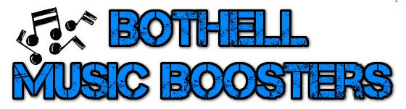
Get on the list!
We are building our email distribution lists for the current school year. This is the primary tool used for communicating with families.
Please submit the following contact information to ensure you hear all the latest BHS Music info!
bothellmusicboosters@gmail.com

(You do not need to include this form if accessing with a mobile device, you may simply email us with your student’s name and their ensemble(s) and your name. You will be added to a mailing list specific to events for that ensemble and any Booster events/fundraisers that include all music programs. You may opt out at any time.)

Student name(s):
Graduation year: (circle/underline): 2022 2023 2024 2025
Ensemble(s): (circle/underline):

Choral Band Orchestra
Parent name(s):
Parent email address(es) (list all emails at which you would like to receive BHS Music News):

Facebook page - "Like" it!
Check out the BHS Music Boosters Facebook page! This page is viewed like a website and is visible to anyone using a search engine. https://www.facebook.com/bothellmusicboosters
Events, volunteer opportunities, reminders, news, accomplishments, and schedule changes are listed here!
Facebook users are encouraged to "Like" the page to receive notifications of events, to make comments or post photos, etc. It is not necessary to have a FB account see the info on the page.

Website: www.bothellmusicboosters.org
Info about Choir, Band, Orchestra events, fundraiser info, donation/store link, and more!
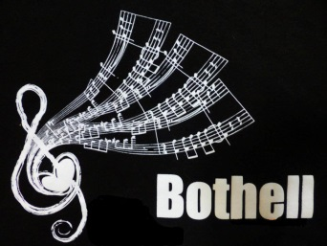
Looking forward to meeting you and your students this year!
Please contact us if you have questions or comments.
Bothell Music Boosters
bothellmusicboosters@gmail.com

