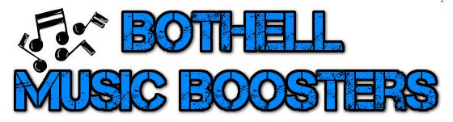
Get on the list!
We are building our email distribution lists for the 2018-19 school year. This is the primary tool used for communicating with families.
Please submit the following contact information to ensure you hear all the latest BHS Music info!
bothellmusicboosters@gmail.com

Student name:
Graduation year: (circle one): 2019 2020 2021 2022
Ensemble/s: (circle all that apply, if known):

Choral Band Orchestra
Symphonic Band Wind Ensemble String Orchestra Chamber Orchestra Jazz Band
Concert Choir Madrigal Singers Bel Cantos Jazz Choir

Instrument/s played (if applicable):
Student email address:
Parent/s name/s:
Parent/s email address/es (list all emails at which you would like to receive BHS Music News):
Parent/s phone # (home and cell #s)

Facebook page - "Like" it!
Check out the BHS Music Boosters Facebook page! This page is viewed like a website and is visible to anyone using a search engine. https://www.facebook.com/bothellmusicboosters
Events, volunteer opportunities, reminders, news, accomplishments, and schedule changes are listed here!
Facebook users are encouraged to "Like" the page to receive notifications of events, to make comments or post photos, etc. It is not necessary to have a FB account see the info on the page.

Website: www.bothellmusicboosters.org
Info about Choir, Band, Orchestra schedules, fundraiser info, PayPal link, and more!
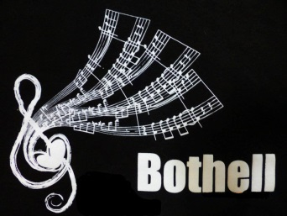
Looking forward to meeting you and your sons and daughters this summer!
Please contact us if you have questions or comments.
Jennifer Shelton for Bothell Music Boosters
Co-Vice President – Instrumental Communications
bothellmusicboosters@gmail.com

